Empirical Project:

Effect of U.S. Government Shutdown on Trump’s Approval Rating

By: Lola Carrola, Mengjia Jiang, Max Lin

**INTRODUCTION**

In this paper, we sought to use econometric analysis to determine the effect of the 2018-2019 U.S. government shutdown on President Donald Trump’s popularity. The government shutdown, which lasted 35 days from December 22, 2018 to January 25, 2019, occurred because of a budget dispute between the White House and Congress. At the time of the event, the president stated he would take full responsibility for the shutdown. To measure Trump’s popularity before, during, and after the shutdown, we used approval and disapproval rating data from FiveThirtyEight, a polling aggregation website owned by ABC News. The purpose of approval ratings is to gauge public support for the president during his term based on poll responses. Historically, presidential approval ratings can widely vary and are highly partisan; however, the approval rating is generally accepted as a statistically valid indicator of the popular mood towards the president.

We sought to answer the additional question of what other factors might provide alternate explanations for trends in Trump’s approval rating, so we included controls representing the volume of Trump’s tweets each day and the public’s perception of the strength of the stock market. We also were curious whether the end of the government shutdown might introduce a new trend in Trump’s approval rating. When performing regression analysis, we used separate independent variables corresponding to the time period during the shutdown and the time period after the shutdown. In analyzing how the the shutdown corresponded to trends in Trump’s approval, we were able to determine that the government shutdown had a significant, negative impact on Trump's popularity.

**DATA**

We found three different types of data: 1) data on Trump’s approval and disapproval 2) data on the volume of Trump’s tweets 3) data on the strength of the stock market.

1. **Trump’s approval data**

We used approval data from FiveThirtyEight, which aggregates a variety of recent polls in its updating estimation of Trump’s current approval and disapproval ratings. FiveThirtyEight tries to include as many polls as possible, as long as they are “real, scientific surveys” (2019). This data is organized by pollster, start date, end date, and weight (essentially, FiveThirtyEight’s judgement of a poll’s reliability and predictive power). For the purposes of this paper, we ignored pollster and weight because our goal was to find a general trend for how the government shutdown affected Trump’s popularity, rather than to make an extremely accurate estimate of Trump’s approval at a given moment in time. For the purpose of our analysis, we decided to identify the date of each poll as the middle date of the poll in order to best indicate what time a specific approval rating is relevant for. We also decided to excluded polls that take place across more than one of the relevant time periods (polls that began before the shutdown and concluded during the shutdown or polls that began during the shutdown and concluded after the shutdown).

1. **Trump’s tweets data**

For our analysis of the effect of Trump’s tweet volume on his approval rating, we used data from http://www.trumptwitterarchive.com/, which provides an up-to-date archive of all of Trump’s tweets. We pulled the time stamps of Trump’s tweets since November 16th, which we used to create a dataset of how many tweets Trump made every day from November 16th to February 14th. For our regression, we used the number of Trump’s tweets the day before the start date of the poll, the most recent volume of tweets that survey respondents could be aware of.

1. **Stock market data**

The stock market data was taken from Yahoo Finance’s updating tracker for the Dow Jones Industrial Average (DJIA). The DJIA is a price-weighted stock index that measures the value of 30 large, public companies traded on the New York Stock Exchange and the Nasdaq. Although swings in the value of the DJIA generally correspond to how the overall stock market is faring, it may not be the most accurate stock index. However, our paper seeks to measure how the stock market affects Americans’ attitudes towards Trump’s presidency, so we were less interested in an accurate measurement of the objective strength of the stock market and more interested in an accurate measurement of people’s perception of the strength of the stock market. For this reason, we chose the Dow Jones, one of the oldest and most-watched stock indices in the world. In our regression analysis, we used the average of the adjusted closing price of the Dow for the five days before the start date of each poll, which we thought would be the best estimator of survey respondents’ perception of the stock market.

When deciding what dates to use as data in our regression, we chose to include dates starting from November 17th, 35 days before the beginning of the government shutdown, so the amount of dates before and during shutdown would be equal. We excluded dates after February 14th, when Trump declared a national emergency at the US-Mexico, a big political event that likely affected his popularity.

To determine the effect of the shutdown on Trump’s approval we used independent variables *daysofsd*, which measures the number of days since the shutdown began and is 0 before and after the shutdown, and *dayspostsd*, which measures the number of days since the shutdown ended and is 0 before and during the shutdown. We also created two dummy variables: *shutdown*, which is 1 during the shutdown and 0 any other time, and *post_shutdown*, which is 1 after the shutdown and 0 any other time.

The summary statistics for this data is included below.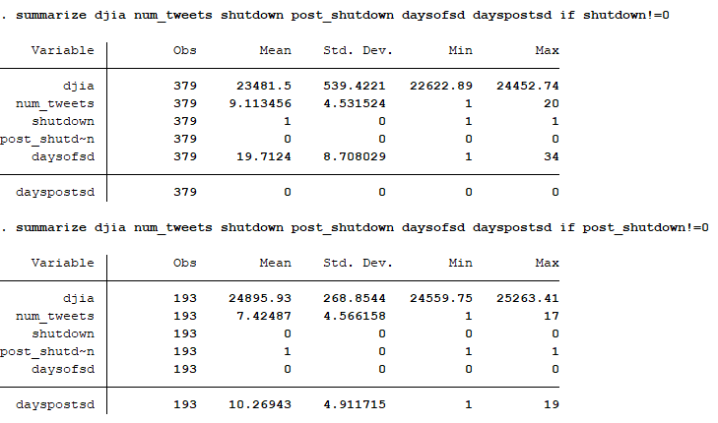

**METHODOLOGY**

After gathering our data, we performed various tests and regressions to analyze Trump’s popularity with respect to our variables. Aside from looking at the relationship between the shutdown and approval rating, we also looked at some control variables, specifically the number of tweets by Trump and the adjusted closing price of the Dow. First, we summarized the data by shutdown status. Next, we ran two regressions, one for *approve* (Trump’s approval rating) against our variables and one for *disapprove* (Trump’s disapproval rating)against our variables. Then, we did an ovtest, which tests for omitted variable bias. After confirming that our data is valid, we graphed scatterplots for *approve* against *daysofsd* and *dayspostsd*; we also fitted a regression line over each of the scatter plots. To test if the data has independent variables and do not exhibit perfect multicollinearity, we used the vif command. Two joint hypothesis tests were carried out to test the significance of *shutdown* and *post_shutdown*, and *daysofsd* and *dayspostsd*.

**RESULTS/ANALYSIS**

**Discussion of Key Assumptions**

The nature of our data affects the 4 Least Squares Assumptions, particularly the second one (which states (X1i ,…,Xki ,Yi ), i =1,…,n, are i.i.d). The data we used from FiveThirtyEight is not independently and identically distributed since Trump’s approval rating is measured over time. Regression models assume independence between output variables for different input values and so a time series analysis might have been more appropriate. There were other assumption we had to make when running our multivariate linear regression. Because it was a linear regression, we tested for a relationship between our independent variables and approval rating to be accordingly linear. A linear regression analysis requires all variables to be normal and assumes no perfect multicollinearity in the data. In our case, we created two dummy variables (*shutdown* and *post_shutdown*) to address any multicollinearity. Then, we used the STATA command vif (variance inflation factor) to test that our independent variables were not perfectly multicollinear.

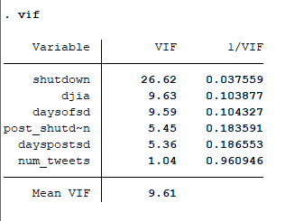

**Figure 1.** Because vif < 10, we do not have the problem of perfect multicollinearity.

Lastly, the regression we ran was a robust regression because we wanted to allow for heteroskedasticity-- STATA’s default is to assume homoscedasticity.

We tested for omitted variable bias in our model using STATA in order to affirm the consistency of our coefficients. Using the ovtest, the null hypothesis is that the model doesn’t have omitted variable bias, and thus the error term and independent variables are not correlated.

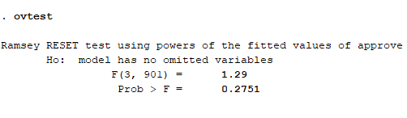

**Figure 2.** Because our p-value is higher than 0.05 (95% significance), we fail to reject the null and can conclude we do not need more variables.

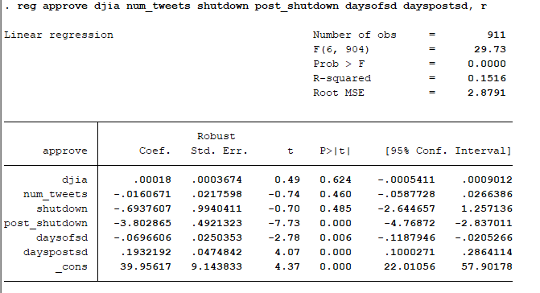

**Figure 3.** The table above shows the multiple linear regression of approval rating against the following variables:

*djia* - DJIA adjusted closing prices

*num_tweets* - number of tweets by Trump from the previous day

*shutdown* - polls taken during shutdown equals one and zero otherwise

*post_shutdown* - polls taken after shutdown equals one and zero otherwise

*daysofsd* - Dec. 22, 2018 is the first day of shutdown, and the count increases by one each day until Jan. 25, 2019. Count equals zero otherwise.

*dayspostsd* - Jan. 26, 2019 is the first day of shutdown, and the count increases by one each day until Feb. 14, 2019. Count equals zero otherwise.

Based on our data and calculations, the following equation represents our regression model of the approval rating for the three periods of shutdown (pre-shutdown, during shutdown, and post-shutdown):

General:

Yi = 𝛽0 + 𝛿0(shutdown)*i* + 𝛿1D*i* + 𝜋0(post_shutdown)*i* + 𝜋1P*i* + 𝜏T*i* + 𝜓S*i* + *ui*

Where,

D*i* ← *daysofsd*

P*i*  ← *dayspostsd*

T*i* ← *num_tweets*

S*i* ← *djia*

Pre-shutdown:

Ŷi = 39.95617 + 0.0018 D*i*- 0.0160671T*i*

During shutdown:

Ŷi = 39.2624093 - 0.0696606D*i* + 0.0018S*i* - 0.0160671T*i*

Post-shutdown:

Ŷi = 36.153305 + 0.1932192P*i* + 0.0018S*i* - 0.0160671T*i*

The regression automatically generated a hypothesis test for each independent variable and the constant, where the null hypothesis tested whether the coefficient equalled zero. Concerning their effect on Trump’s approval rating, *post_shutdown, daysofsd, dayspostsd* were significant at a 0.05 significance level. Variables that were not significant were *djia, num_tweets, and shutdown*.

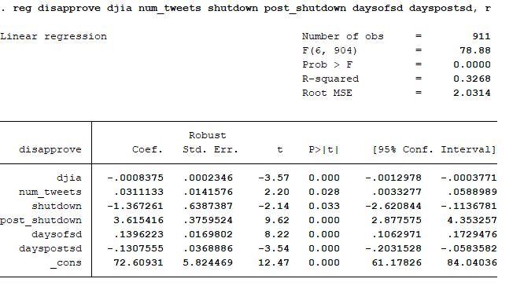

**Figure 4.** We also ran a regression almost exact to the earlier one, this time using the disapproval rating. The results compliment what we found regressing presidential approval.

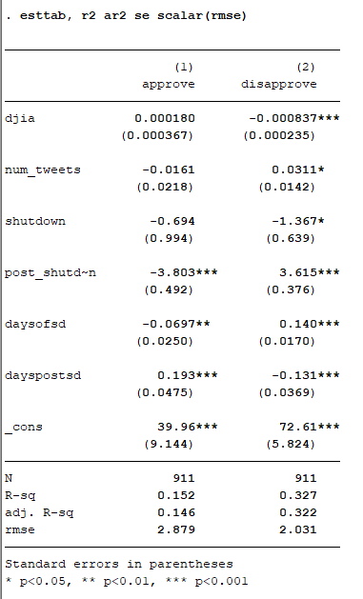

**Figure 5.** We can show our models side-by-side by using a regression table.

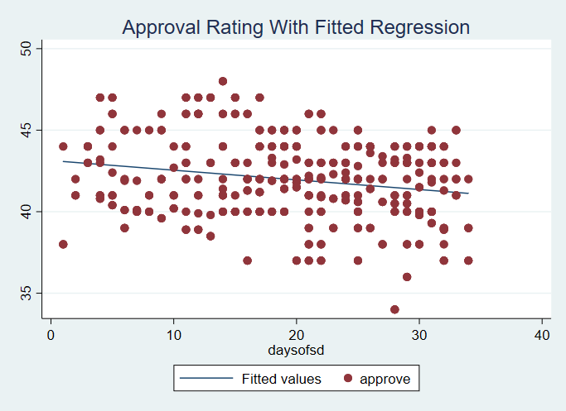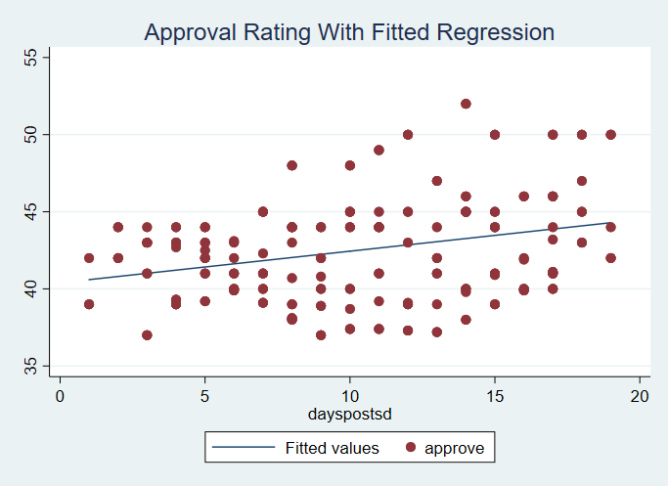**Figure 6.** Graphing the regression line over our data using a scatter plot allows us to view any outliers that may have occurred.

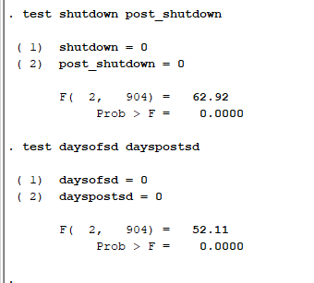

**Figure 7.** We ran two joint hypothesis tests. The first one tested whether our variables *shutdown* and *post_shutdown* were 95% significant, with our null hypothesis being they both equaled zero. The F-statistic was 0, meaning the variables are significant. This means that the shutdown was significant in affecting presidential approval. The second hypothesis test tested the significance of our two variables: *daysofsd* and *dayspostsd*. The F-statistic for this was again 0, meaning the variables are 95% significant. The interpretation of this is that not only the shutdown as an event was significant, but the length of the shutdown and length of recovery (days post-shutdown) also significantly affected presidential approval ratings.

**CONCLUSION**

In this paper, we aimed to determine what effect the 2018-2019 U.S. government shutdown had on Donald Trump’s popularity. Using data from various polls, Trump’s twitter, and the DJIA, we performed multiple linear regression and found that the government shutdown did have a significant, negative impact on Trump’s approval rating while the effect of Trump’s tweet volume and the stock market were not significant. We believe that these conclusions are accurate. The limitations of polling data and the complexity of the factors potentially affecting Trump’s approval make it difficult to give a more precise, quantitative answer for the effect of the shutdown on Trump’s popularity.

One additional question we had was whether or not the end of the shutdown would signal a new trend in Trump’s popularity. From performing regression with the variable dayspostsd, we were able to determine that the end of the shutdown corresponded to a new trend of growing approval for Trump. There are a couple possible interpretations for this: 1) the weeks after the shutdown were a recovery period for Trump’s popularity, when his approval returned to its pre-shutdown state 2) the end of the shutdown was a boost for Trump’s popularity, leading to more and more American approving of his presidency. In other words, did the end of the shutdown cause Americans to revert to their pre-shutdown attitudes towards Trump, or did Trump’s role in ending the shutdown attract new support? This is a potential question for future studies.

**REFERENCES**

538. “How Popular Is Donald Trump?” *FiveThirtyEight*, 1 Mar. 2019, projects.fivethirtyeight.com/trump-approval-ratings/.

“DJI Historical Prices | Dow Jones Industrial Average Stock.” *Yahoo! Finance*, Yahoo!, 1 Mar. 2019, finance.yahoo.com/quote/^DJI/history?p=^DJI.

Kenton, Will. “Dow Jones Industrial Average (DJIA).” Investopedia, Investopedia, 21 Feb. 2019, www.investopedia.com/terms/d/djia.asp.

*Trump Twitter Archive*, www.trumptwitterarchive.com/archive.

**LINK**

<https://github.com/lola-carr/trump_shutdown_approval>